DDCQIP

- Quality of Care in 2002

Division program | Feature | Y/N | N | % 6+ QoC | 95% CI | Chi Square  (p)
CPD programs | Diabetes clinical placements | N | 7656 | 30.5 | 29.47-31.53 | 74.5  (<0.001)
CPD programs | Diabetes clinical placements | Y | 474 | 49.6 | 45.10-54.10 | 74.5  (<0.001)
CPD programs | Clinical audit | N | 1138 | 42.4 | 39.53-45.27 | 114  (<0.001)
CPD programs | Clinical audit | Y | 6992 | 29.8 | 28.73-30.87 | 114  (<0.001)
CPD programs | Peer review | N | 4189 | 34.7 | 33.26-36.14 | 38.7  (<0.001)
CPD programs | Peer review | Y | 3941 | 28.3 | 26.89-29.71 | 38.7  (<0.001)
CPD programs | Group learning | N | 5222 | 35.9 | 34.60-37.20 | 125  (<0.001)
CPD programs | Group learning | Y | 2908 | 23.8 | 22.25-25.35 | 125  (<0.001)
Diabetes guideline | Development | N | 4909 | 37.0 | 35.65-38.35 | 167  (<0.001)
Diabetes guideline | Development | Y | 3221 | 23.4 | 21.94-24.86 | 167  (<0.001)
Diabetes guideline | Dissemination | N | 2052 | 33.9 | 31.85-35.95 | 6.8  (<0.01)
Diabetes guideline | Dissemination | Y | 6078 | 30.8 | 29.64-31.96 | 6.8  (<0.01)
Diabetes data provision | Practitioners within same practices | N | 3159 | 40.0 | 38.29-41.71 | 170  (<0.00
Diabetes data provision | Practitioners within same practices | Y | 4971 | 26.2 | 24.98-27.42 | 170  (<0.00
Diabetes data provision | Diabetes practitioners in different practices | N | 5789 | 29.1 | 27.93-30.27 | 57.6  (<0.001)
Diabetes data provision | Diabetes practitioners in different practices | Y | 2341 | 37.8 | 35.84-39.76 | 57.6  (<0.001)
Diabetes program model | Miniclinic |  | 581 | 45.4 | 41.35-49.45 | 83.5  (<0.001)
Diabetes program model | Multidisciplinary team |  | 3937 | 27.9 | 26.50-29.30 | 83.5  (<0.001)
Diabetes program model | Structured shared care |  | 2366 | 32.4 | 30.51-34.29 | 83.5  (<0.001)
Diabetes program model | Refer to diabetes centre/Cardiac rehab centre |  | 718 | 36.9 | 33.37-40.43 | 83.5  (<0.001)
Diabetes program model | Other |  | 528 | 32.6 | 28.60-36.60 | 83.5  (<0.001)
Diabetes Program | Outreach | N | 4321 | 25.4 | 24.10-26.70 | 162  (<0.001)
Diabetes Program | Outreach | Y | 3809 | 38.6 | 37.05-40.15 | 162  (<0.001)

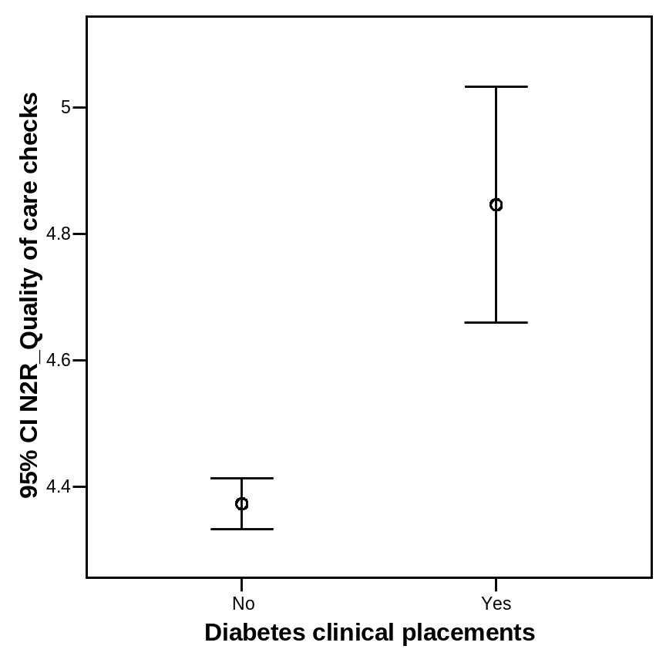

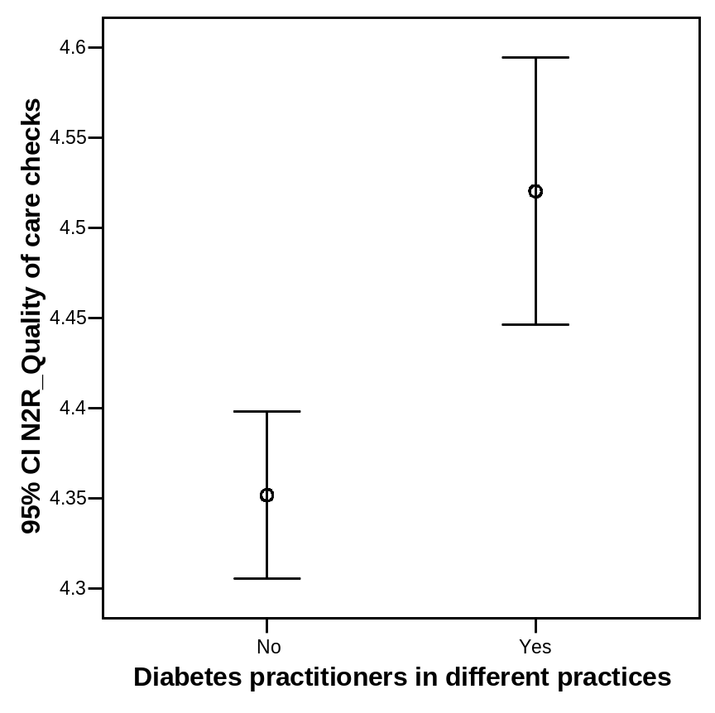

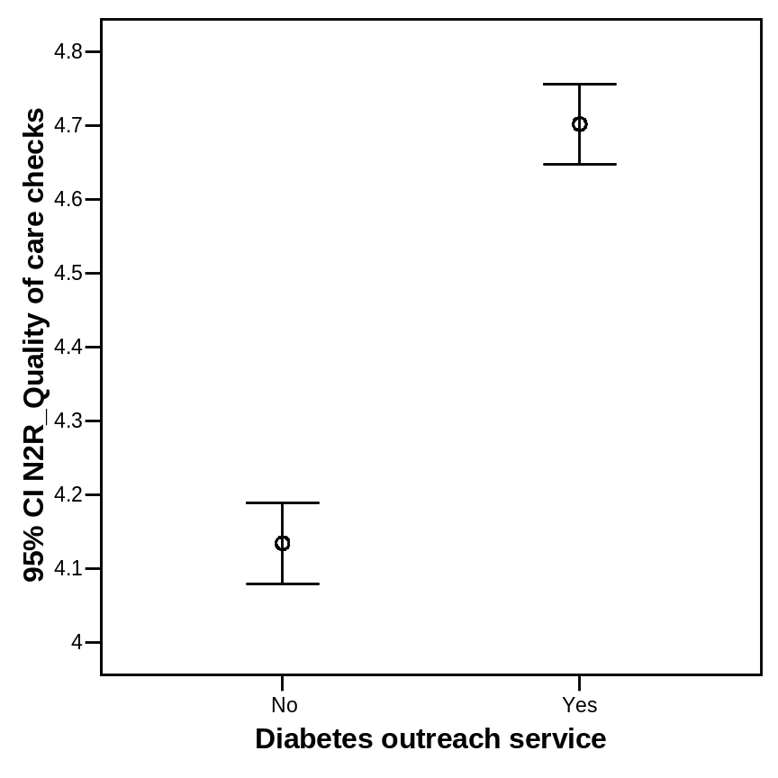

- HbA1c

Mean HbA1c levels recorded in 2002
Division program | Feature | Y/N | N | Mean | St Dev | 95% CI | ANOVA
Division CPD activities | Diabetes clinical placements | N | 5059 | 7.64 | 14.98 | 7.23-8.05 | NS
Division CPD activities | Diabetes clinical placements | Y | 397 | 7.17 | 1.26 | 7.05-7.29 | NS
Division CPD activities | Clinical audit | N | 942 | 7.38 | 1.47 | 7.29-7.47 | NS
Division CPD activities | Clinical audit | Y | 4514 | 7.66 | 15.85 | 7.20-8.12 | NS
Division CPD activities | Peer review | N | 3188 | 7.56 | 12.50 | 7.13-7.99 | NS
Division CPD activities | Peer review | Y | 2268 | 7.67 | 16.77 | 6.98-8.36 | NS
Division CPD activities | Group learning | N | 4165 | 7.70 | 16.49 | 7.20-8.20 | NS
Division CPD activities | Group learning | Y | 1291 | 7.32 | 1.57 | 7.23-7.41 | NS
Diabetes guideline | Development | N | 3976 | 7.72 | 16.88 | 7.20-8.24 | NS
Diabetes guideline | Development | Y | 1483 | 7.32 | 1.52 | 7.24-7.40 | NS
Diabetes guideline | Dissemination | N | 1762 | 7.39 | 1.58 | 7.32-7.46 | NS
Diabetes guideline | Dissemination | Y | 3694 | 7.71 | 17.50 | 7.15-8.27 | NS
Diabetes data provision to | Diab Practitioners within practices | N | 2246 | 7.35 | 1.45 | 7.29-7.41 | NS
Diabetes data provision to | Diab Practitioners within practices | Y | 3210 | 7.79 | 18.77 | 7.14-8.44 | NS
Diabetes data provision to | Diabetes practitioners in different practices | N | 3555 | 7.58 | 13.62 | 7.13-8.03 | NS
Diabetes data provision to | Diabetes practitioners in different practices | Y | 2001 | 7.65 | 15.73 | 6.96-8.34 | NS
Diabetes program model | Miniclinic |  | 438 | 7.33 | 1.45 | 7.19-7.47 | NS
Diabetes program model | Multidisciplinary team |  | 2171 | 8.03 | 22.80 | 7.07-8.99 | NS
Diabetes program model | Structured shared care |  | 1739 | 7.29 | 1.37 | 7.23-7.35 | NS
Diabetes program model | Refer to diabetes centre/Cardiac rehab centre |  | 628 | 7.43 | 1.65 | 7.30-7.56 | NS
Diabetes program model | Other |  | 480 | 7.36 | 1.70 | 7.21-7.51 | NS
Diabetes Program | Outreach | N | 2239 | 7.97 | 22.45 | 7.04-8.90 | NS
Diabetes Program | Outreach | Y | 3218 | 7.35 | 1.52 | 7.30-7.40 | NS

